Open Account

* The system displays the New Account Page.

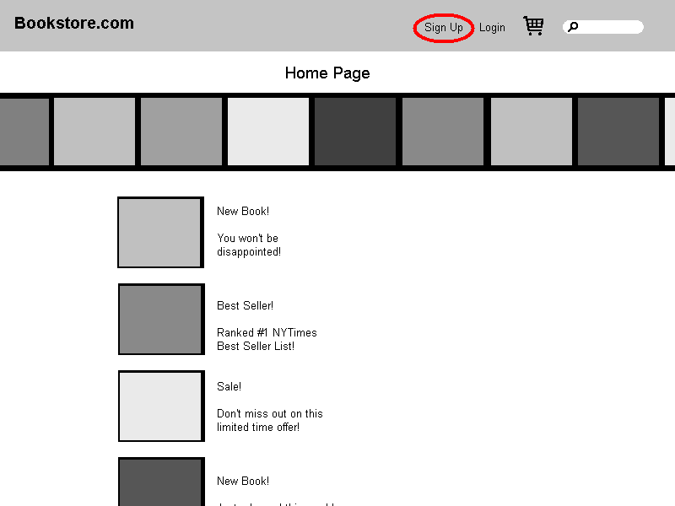

* The Customer types his or her name, an e-mail address, and a password (twice), and then presses the Create Account button.

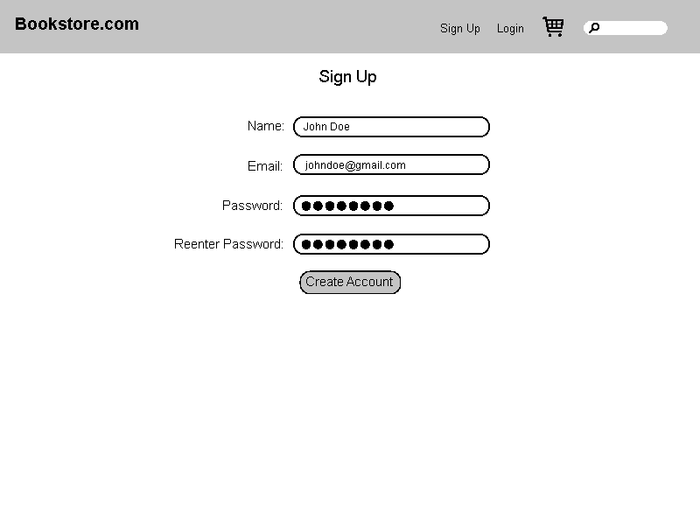

* The system ensures that the Customer has provided valid data and then adds an Account to the Master Account Table using that data. Then the system returns the Customer to the Home Page

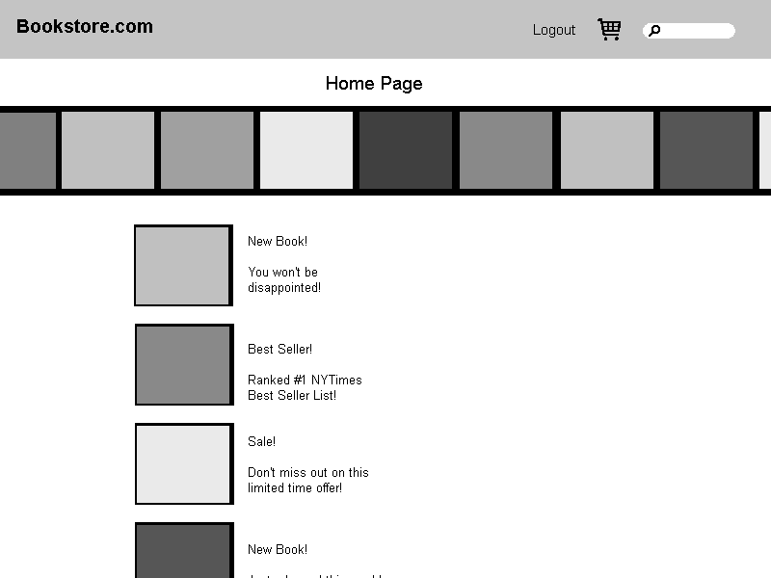

* + If the Customer did not provide a name, the system displays an error message to that effect and prompts the Customer to type a name.

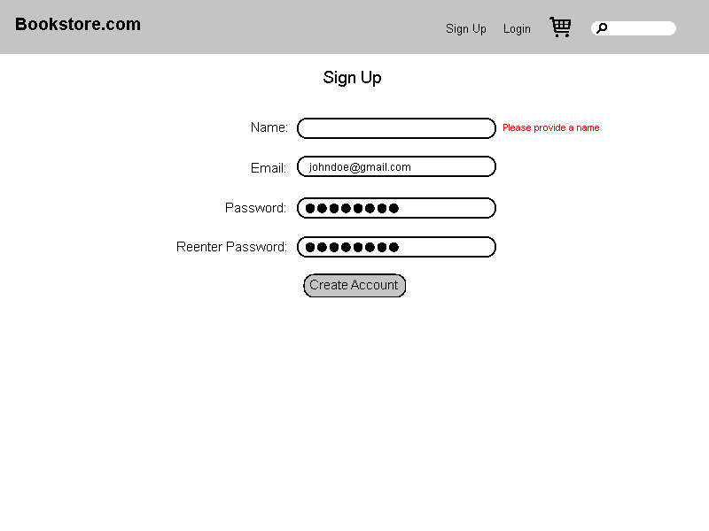

* + If the Customer provided an email address that's not in the correct form, the system displays an error message to that effect and prompts the Customer to type a different address.

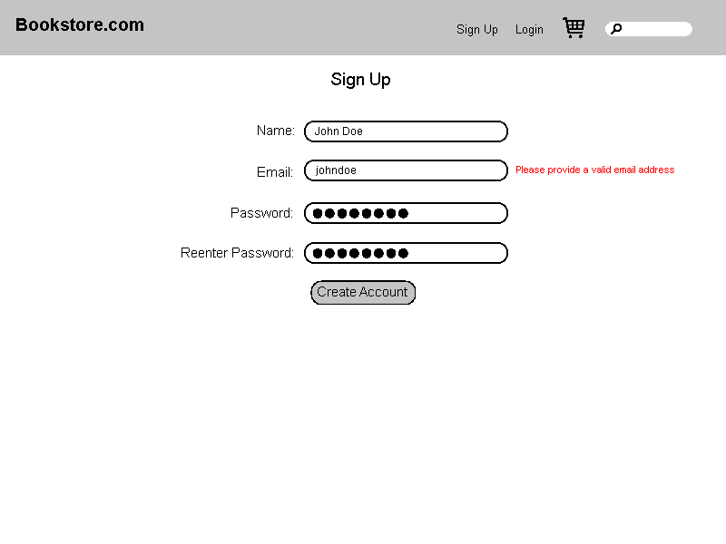

* + If the Customer provided a password that is too short, the system displays an error message to that effect and prompts the Customer to type a longer password.

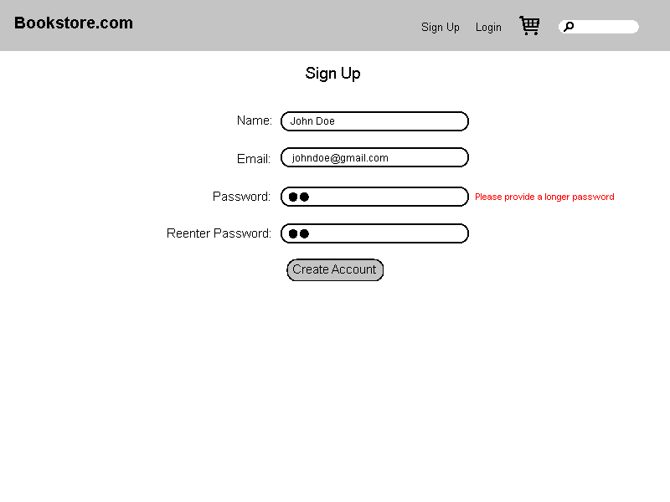

* + If the Customer did not type the same password twice, the system displays an error message to that effect and prompts the Customer to type the password correctly the second time.

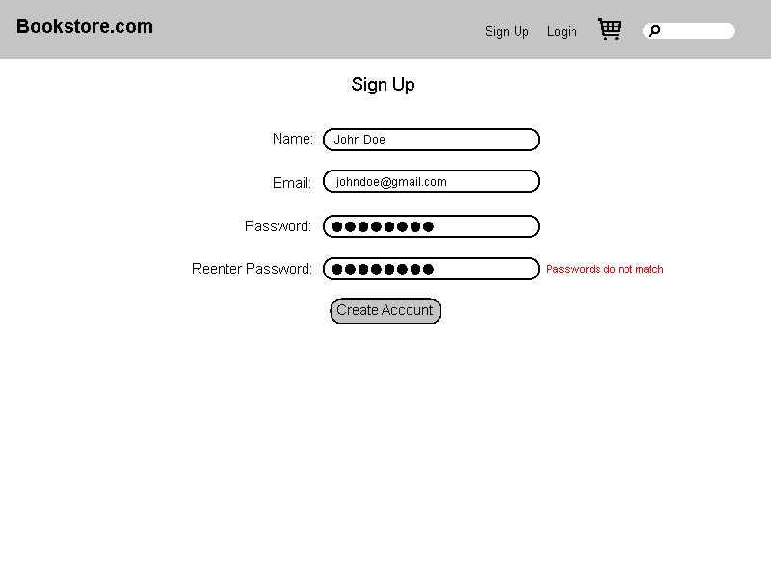

* + If the account is already in the master account table, notify the user.

